**HTML | <track> src Attribute**

Last Updated : 19 Jul, 2022

The **HTML <track> src Attribute** is used to specify the URL of the track.

**Syntax:**

<track src="subtitles_en.vtt">

**Attribute Values:** It contains single value **URL** which is used to specify the URL of the track.

Below example illustrates the use of src attribute in <track> element.

**Example:**

* html

|  |
| --- |
| <!DOCTYPE html>  <html>    <head>      <style>          body {              text-align: center;          }            h1 {              color: green;          }      </style>  </head>    <body>      <h1>GeeksforGeeks</h1>      <h3> HTML Track src Attribute </h3>        <video width="400" height="200" controls>            <track src=  "[https://media.geeksforgeeks.org/wp-content/uploads/20190626010302/ice_video_20190626-005104_edit_0.mp4"](https://media.geeksforgeeks.org/wp-content/uploads/20190626010302/ice_video_20190626-005104_edit_0.mp4%22)                 kind="subtitles" srclang="en" label="English">                <source id="myTrack" src=  "[https://media.geeksforgeeks.org/wp-content/uploads/20190626010302/ice_video_20190626-005104_edit_0.mp4"](https://media.geeksforgeeks.org/wp-content/uploads/20190626010302/ice_video_20190626-005104_edit_0.mp4%22)                                              type="video/mp4">      </video>  </body>    </html> |

**Output:**

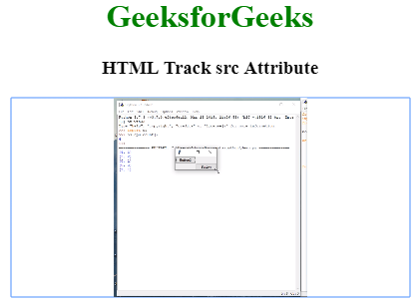

**Supported Browsers:** The browser supported by HTML <track> src Attribute are listed below:

* Google Chrome 23.0
* Edge 12.0
* Internet Explorer 10.0
* Firefox 31.0
* Safari 6.0
* Opera 12.1